1. Do you currently ride a bicycle or use any other form of alternative transportation?
I have a Trek 1200 that I ride 3-4 times a week, usually stopping off at city hall if I don’t have a formal meeting that day. I put on about 2500 miles a year, which I do mostly for health reasons. I take advantage of Bean Creek Rd, which is about a 10 mile bucolic ride, with virtually no vehicles to contend with. Scotts Valley Dr. is a very safe road as there are no parked vehicles on it and the speed limit is 35 MPH, but as you know, distracted drivers with cell phones are always an issue. I have told the story that one October I was hit in the back with a Snickers bar from a passing truck, while riding on Scotts Valley Dr. so around Halloween I have to have my guard up a little more.
2. What specific accomplishments and qualifications demonstrate your capacity to improve the transportation system in your community

The City received a safe-routes to school grant that allowed for the construction of new sidewalk and bike/pedestrian paths from Vine Hill Elementary, through Siltanen Park to the high school. This work was completed in late 2014. (Tough project as some of the neighbors were opposed)
We will be placing a new bike lane on MHR from the Skypark Drive area through the intersection at Lockhart Gulch. This is currently the only area on MHR that does not have a bike lane. This will happen this fall.
We just received a grant to repave and add a bike lane on Green Hills Road. Currently there is a bike lane for NB bike traffic on Green Hills,, but no bike lane for SB traffic. Portions of Glen Canyon are also included in this grant (a very dicey stretch) This work should take place in the spring/summer of 2018.

3. The 2012 Scotts Valley Bicycle Transportation Plan includes the following objectives. How do you plan to lead the City in achieving these goals?
- Increase use of bicycling for short- and long-range trips, and reduce the use of motor vehicles;
- Develop funding sources for bicycle transportation system implementation and maintenance.
As our city becomes more financially stable in the coming years, we will have the funds to pursue programs described above. Our staff takes grant opportunities very seriously and we have been successful in receiving many grants, including those that help implement these goals.

4. In many cases, adding new facilities for people on bikes requires parking removal. How would you balance the concerns of people on bikes with those of who oppose removal of parking spaces?
Parking removal in Scotts Valley to allow for more opportunities for bicyclists has not been an issue and I don’t anticipate it to be one.

5. Implementing innovative bike treatments like protected bikeways has been shown to dramatically increase bike ridership in cities across the U.S. Do you consider these facilities to be of value? If so, how would you propose to implement them in your district?

As a RTC commissioner, I am a big fan of the bike trail along the rail corridor sans the rail line. The rail part I think really delays the opportunity to have a first-class trail.

Protected bikeways work with enough real estate and funding. Always open to possibilities when feasible.

6. Santa Cruz County is consistently ranked #1 or #2 in the state for cyclist injuries and fatalities. What steps would you take to improve safety for people on bikes?

Our police department is very good in traffic enforcement and cell phone violations. That is a big part in identifying distracted drivers, which we all know is a threat to cyclists.

7. How do you plan to create new safe routes to schools in your district?
Please see above

8. What else would you like our members to know about you? Please include how your campaign can be contacted, such as your website, email, telephone, Facebook page, or other methods you want to share. RLJ12@comcast.net 359-2099

Thank you for your consideration.

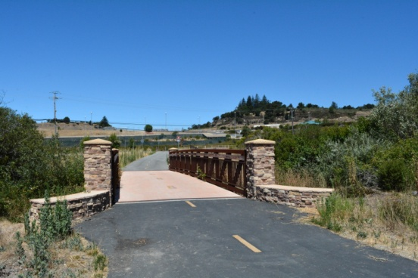 Safe routes to school

